**ASSIGNMENT**

**ON**

**LAB TASK 2**

**SUBMITTED BY: KASHAN HUMAYUN**

**SUBMITTED TO: QAZI SHUJAH UL DIN**

**SAP ID : 24773**

**SUBJECT : DATABASE LAB**

**FACULTY OF COMPUTER SCIENCES**

**RIPHAH INTERNATION UNIVERSITY**

**Lab task :**

* **Write a query to show job start date and job end date of those employees whose department id is 110 and job title is ‘AC_ACCOUNT’**

select start date, end date from employees

where department_id=110 and job_title=’AC_ACCOUNT’

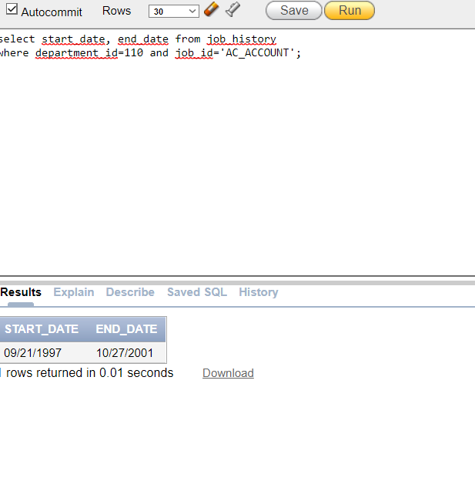

* **Write a query to display job_id and min salary from those jobs whose job title ‘President and maximum salary is 400000**

Select job_id, min_salary From jobs

Where job_title=’President’ and max_salary=400000;

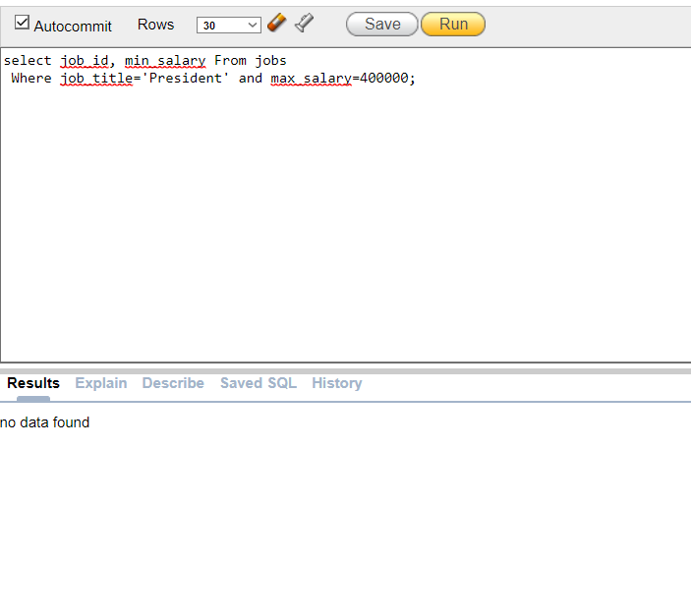

* **Write a query to display employee number, first name, job title ,salary form those employees whose salary is greater than equal to 1100 or job_id is ‘IT_PROG’**

SELECT employee_id,first_name, job_id ,salary from employees

where salary>=1100 or job_id =’IT_PROG’;

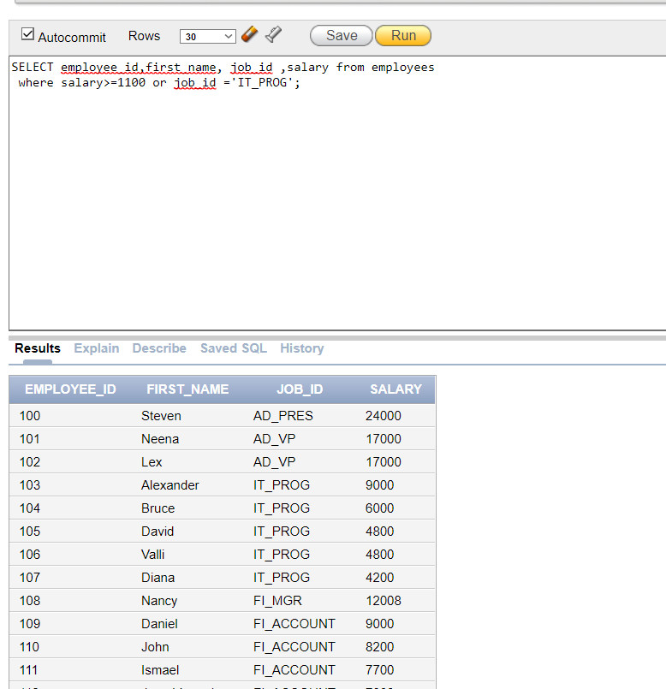

* **Write a query to display salary and job tile of those employee whose salary is greater than 4000 or job title IT_PROG**

select job_id,salary from employees

where salary>=4000 or job_id='IT_PROG';

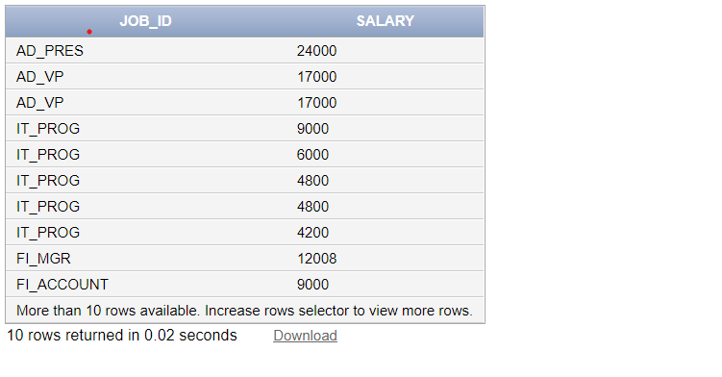

* **Write a query to show country code, country name of those employees whose country name ‘Argentina’ or region id 4**

select country_id,country_name from countries

where country_name='Argentina' or region_id='4';

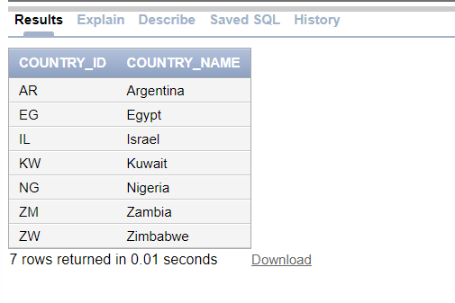

* **Write a query to display first_name,job title form those employees whose job title not in st_clerk and programmer.**

Select first_name,job_id From employees

Where job_id not in (‘ST_CLERK’, ‘PROGRAMMER’);

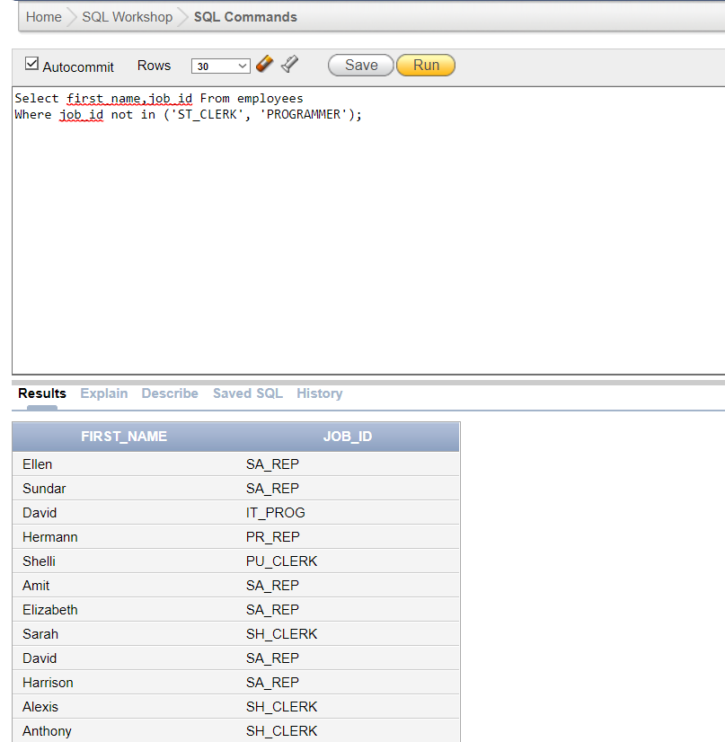

**Lab task 2:**

* **Write a query to display employee_id,salary from those employees where department_id not 50 and 80.**

select employee_id,salary from employees

where department_id not in(50,80);

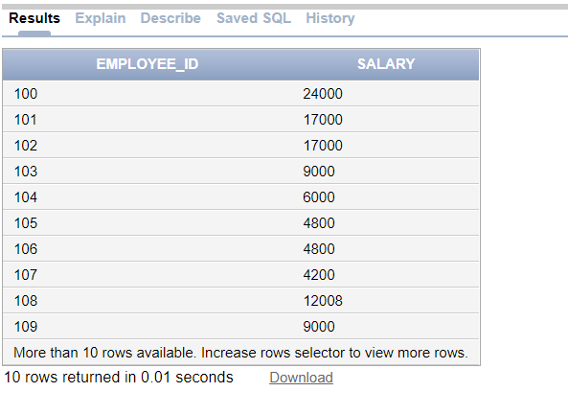

* **Write a query to show all country name is descending order**

SELECT first_name,department_id,salary from employees order by department_id , salary desc;

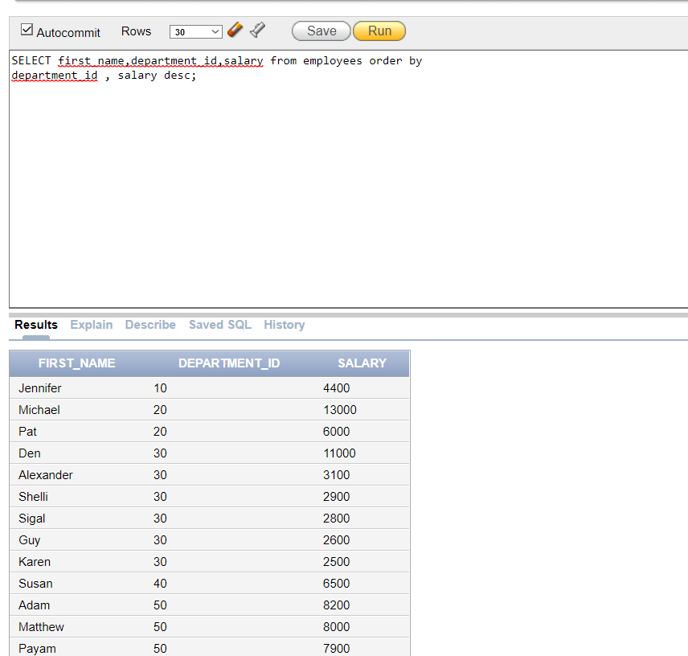

* **Write a query to show all records in job_history except those records whose Job_id (‘IT_PROG’, ‘AC_ACCOUNT’)**

select * from job_history

where job_id not in('IT_PROG','AC_ACCOUNT');

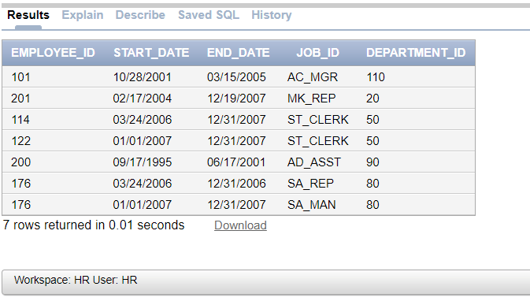

**Lab Task**

* **Write a query to display full name of that employees whose first name contains ‘a’ and salary is 6000, 8400, 8600 and 6100. Display the full name of each employee, and please note each name is right justify.**

select lpad(concat(first_name,last_name),20,'*') as Full_Name from employees

where first_name like '%a%' and salary in(6000,8400,8600,6100);

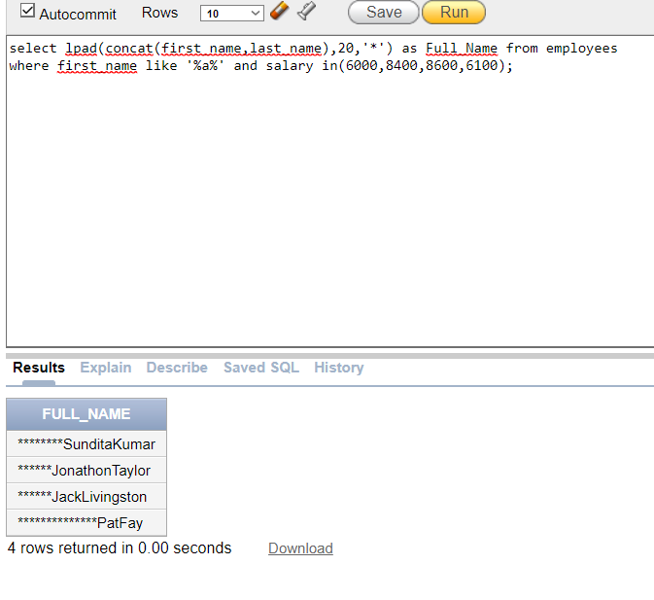

Lab Task 2

* **Write a query to show all country name in small letter and display all records in country table**

select lower(country_name) as country_name, country_id, region_id from countries;

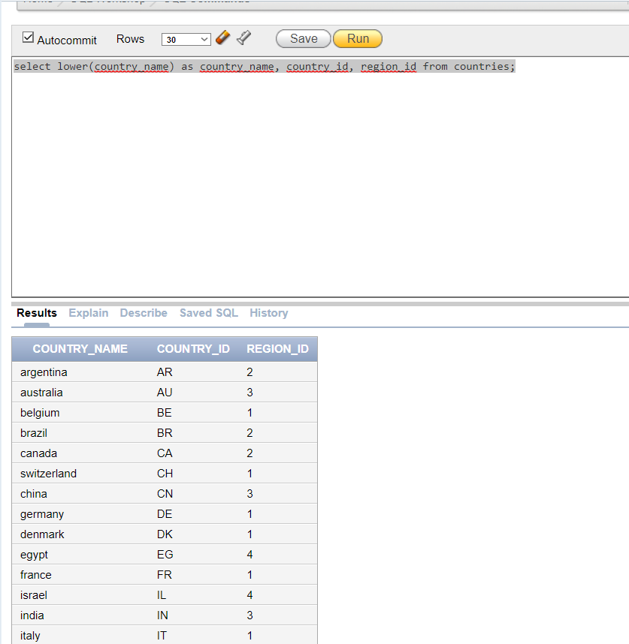

* **Write a query to show all employees-name in capital letters of those employee whose salary range in 6000 to 12000.**

select upper(first_name) as employee_name from employees

where salary between 6000 and 12000;

